Math 10

Lesson 2–1 Answers

**Lesson Questions**

**Question 1**

a) 24, 14

b) 61, 84, x2

c) x5

d) 4x3

**Question 2**

Determine the GCF of each pair of terms.

a) 5mn

b) 12ab2c

**Question 3**

Write each polynomial in factored form.

a) 9rs2(3r – 2r2 – 4s)

b) 2np(2p + 5n3 – 6n2)

**Question 4**

Write each expression in factored form.

a) (4 – 3x)(x + 5)

b) a2 + 8ab + 2a + 16b

= (a2 + 8ab) + (2a + 16b)

= a(a+ 8b) + 2(a + 8b)

= (a + 2)(a+ 8b)

**Assignment**

1. a) 3ab b) 27m2n c) 8x2y2 d) 4a2c e) p3q3

2. a) 5(x + 3) b) y(3y – 5) c) w2(x + y – z) d) 6ab(a2 – 3b) e) 3x(3x2 – 4x + 2)

3. a) 3ab b) s2 – 5 c) d – 7 d) 8x – 1 e) 4xy

4.

a)



b)



c)



d)



e)



5.

a) 12v2 + 18v

b) 4x2y – 6y2

c) 12n4 – 6n2 + 2n

d) 24m3n2 + 21mn3 – 12mn2

6.

a) Incorrect: 3x ÷ 3x ≠ 0

Correct: 3x(5x – 1)

b) Incorrect: (x – 2) ÷ (x – 2) ≠ 0

Correct: (x – 2)(5x – 1)

c) Incorrect: GCF ≠ 9ab

Correct: 9a2b2 (b – 3 + 9ab)

d) Incorrect: factoring incomplete

Correct: 2(x + 4)(2f + 1)

e) Incorrect: expression not simplified

Correct: 2(p2 – 7p – 5)



8r

7.

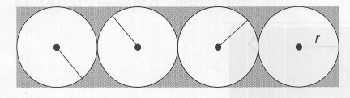

2r

l

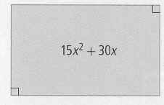

8.



w

9. First, identify the even multiples of 871: 871, 1742, 2613, 3484, 4355, 5226

Second, divide to find which are not divisicle 

Therefore the smallest numbers are 3484 and 5226